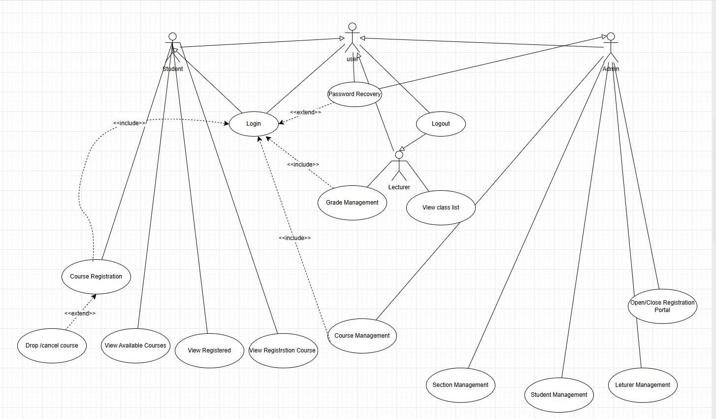

PROJECT REPORT: COURSE REGISTRATION SYSTEM (CRS)
Phases: Requirements Analysis, Specification, and Design

I. REQUIREMENTS ANALYSIS & SPECIFICATION (

1. Actor Identification
To ensure system modularity and the DRY (Don't Repeat Yourself) principle, we categorize actors as follows:
- Base Actor: User – Represents any person authenticated by the system.
- Specialized Actors: Student, Lecturer, and Admin. These actors inherit all capabilities from the User actor.

2. Functional Requirements
The system's functionalities are organized into four main groups:
A. Authentication (Common for all Users):
- Login: Mandatory for system access.
- Logout: Terminates the current session.
- Password Recovery (Extend): Optional flow triggered when a user forgets credentials.
B. Student Modules:
- View Available Courses.
- Course Registration (Include Login).
- Drop/Cancel Course (Extend Course Registration).
- View Registered Schedule.
C. Lecturer Modules:
- View Class List.
- Grade Management (Include Login).
D. Administrator Modules:
- Course & Section Management.
- User Management (Student/Lecturer).
- System Portal Control (Open/Close registration).

